

# 

### Semester Two Examination, 2017

### Question/Answer booklet

# MATHEMATICS

**SOLUTIONS**

**APPLICATIONS**

**UNITS 1 AND 2**

## Section One:

## Calculator-free

|  |  |  |  |  |  |  |  |  |  |  |
| --- | --- | --- | --- | --- | --- | --- | --- | --- | --- | --- |
| Student Number: In figures |  |  |  |  |  |  |  |  |  |  |

In words

Your name

## Time allowed for this section

Reading time before commencing work: five minutes

Working time: fifty minutes

## Materials required/recommended for this section

***To be provided by the supervisor***

This Question/Answer booklet

Formula sheet

***To be provided by the candidate***

Standard items: pens (blue/black preferred), pencils (including coloured), sharpener, correction fluid/tape, eraser, ruler, highlighters

Special items: nil

## Important note to candidates

No other items may be taken into the examination room. It is **your** responsibility to ensure that you do not have any unauthorised material. If you have any unauthorised material with you, hand it to the supervisor **before** reading any further.

## Structure of this paper

|  |  |  |  |  |  |
| --- | --- | --- | --- | --- | --- |
| Section | Number of questions available | Number of questions to be answered | Working  time (minutes) | Marks available | Percentage of examination |
| Section One:  Calculator-free | 6 | 6 | 50 | 52 | 35 |
| Section Two:  Calculator-assumed | 13 | 13 | 100 | 98 | 65 |
|  | | |  | **Total** | 100 |

## Instructions to candidates

1. The rules for the conduct of examinations are detailed in the school handbook. Sitting this examination implies that you agree to abide by these rules.

2. Write your answers in this Question/Answer booklet.

3. You must be careful to confine your response to the specific question asked and to follow any instructions that are specified to a particular question.

4. Additional working space pages at the end of this Question/Answer booklet are for planning or continuing an answer. If you use these pages, indicate at the original answer, the page number it is planned/continued on and write the question number being planned/continued on the additional working space page.

5. Show all your working clearly. Your working should be in sufficient detail to allow your answers to be checked readily and for marks to be awarded for reasoning. Incorrect answers given without supporting reasoning cannot be allocated any marks. For any question or part question worth more than two marks, valid working or justification is required to receive full marks. If you repeat any question, ensure that you cancel the answer you do not wish to have marked.

6. It is recommended that you do not use pencil, except in diagrams.

7. The Formula sheet is not to be handed in with your Question/Answer booklet.

Section One: Calculator-free 35% (52 Marks)

This section has**six (****6)** questions. Answer **all** questions. Write your answers in the spaces provided.

Working time: 50 minutes.

Question 1 (7 marks)

A vehicle accelerates along a road. The distance d of the vehicle from its starting point at time $t$ is given by the formula $d=\frac{1}{4}at^{2}$, where $a$ is the acceleration.

(a) Calculate $d$ when

(i) $a=2$ and $t=1$. (1 mark)

|  |
| --- |
| **Solution** |
| $$d=\frac{1}{4}×2×1×1=\frac{1}{2}$$ |
| **Specific behaviours** |
| ✓ calculates value |

(ii) $a=\frac{1}{2}$ and $t=4$. (1 mark)

|  |
| --- |
| **Solution** |
| $$d=\frac{1}{4}×\frac{1}{2}×4×4=2$$ |
| **Specific behaviours** |
| ✓ calculates value |

(b) Calculate the distance travelled by the body between $t=1$ and $t=2$ when $a=8$.

(3 marks)

|  |
| --- |
| **Solution** |
| $$d_{1}=\frac{1}{4}×8×1×1=2$$ $$d_{2}=\frac{1}{4}×8×2×2=8$$ $$d=8-2=6$$ |
| **Specific behaviours** |
| ✓ calculates  ✓ calculates  ✓ calculates difference |

(c) Determine $a$ when $d=160$ and $t=8$. (2 marks)

|  |
| --- |
| **Solution** |
| $$160=\frac{1}{4}×a×8×8$$ $$160=16a$$ $$a=10$$ |
| **Specific behaviours** |
| ✓substitutes and simplifies  ✓ states value of $a$ |

Question 2 (12 marks)

The marks of 60 students in an exam are listed below in descending order and summarised in the histogram.

78, 77, 76, 73, 72, 71, 70, 70, 69, 68, 67, 65, 64, 64, 63,

63, 63, 63, 63, 63, 62, 61, 61, 61, 61, 60, 60, 60, 60, 59,

59, 59, 59, 58, 58, 57, 57, 57, 56, 56, 56, 56, 55, 55, 55,

55, 54, 54, 54, 53, 53, 52, 52, 52, 51, 50, 50, 49, 48, 47.

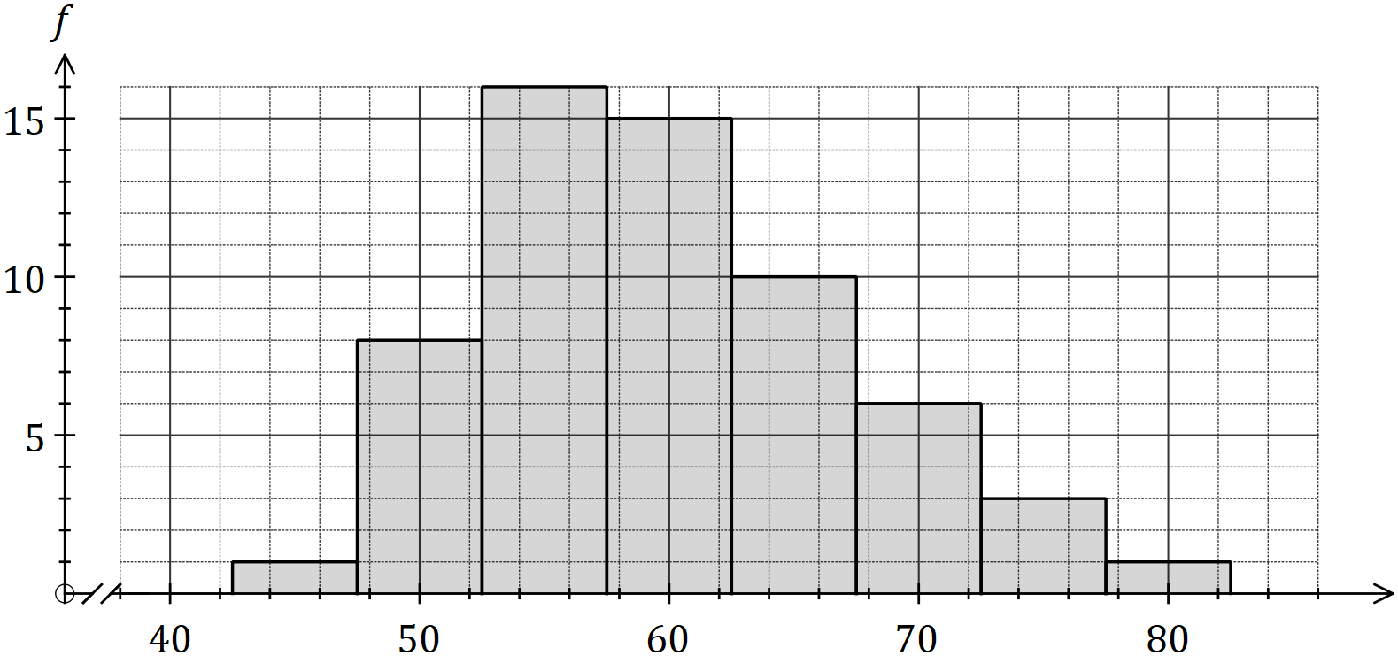

(a) Describe the shape of the distribution of marks in terms of modality and shape. (2 marks)

|  |
| --- |
| **Solution** |
| The scores are unimodal, with just one peak, and most of them are bunched around the high fifties to low sixties. The spread of scores is not very symmetrical, and a tail to the right indicates positive skew. |
| **Specific behaviours** |
| ✓ indicates unimodal  ✓ indicates positive skew |

(b) State the

|  |
| --- |
| **Solution** |
| Median: 59  Mode: 63  Range: 31  IQR: $63-55=8$ |
| **Specific behaviours** |
| ✓ median  ✓ mode  ✓ range  ✓ identifies $Q_{1}$ and  ✓ IQR |

(i) median mark. (1 mark)

(ii) modal mark. (1 mark)

(iii) range of marks. (1 mark)

(iv) inter-quartile range of marks. (2 marks)

The marks of another group of students, group B, who sat the same exam are shown in the box plot below.

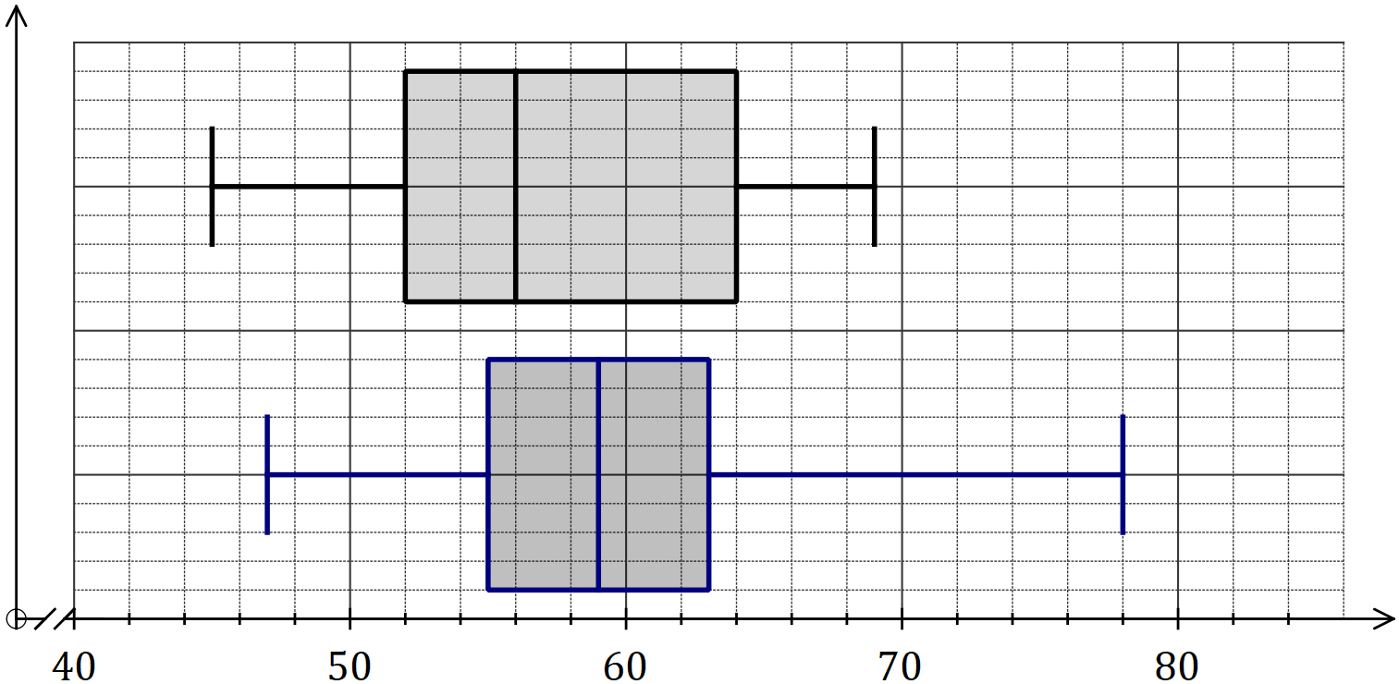

(c) Add a box plot on the axes above for the data given on the previous page for group A.

(3 marks)

|  |
| --- |
| **Solution** |
| See graph |
| **Specific behaviours** |
| ✓ indicates neat box and whiskers  ✓ correct min, max and median  ✓ correct $Q_{1}$ and $Q_{3}$ |

(d) Use information from the box plots to compare the performance of group A and group B in the exam. (2 marks)

|  |
| --- |
| **Solution** |
| Group A performed better, as their median was higher than that of group B.  Group A had a smaller IQR, indicating that their marks were less spread, and thus more consistent, than those of group B. |
| **Specific behaviours** |
| ✓ statement using median  ✓ statement using IQR |

Question 3 (7 marks)

(a) The graphs of three straight lines are shown below.

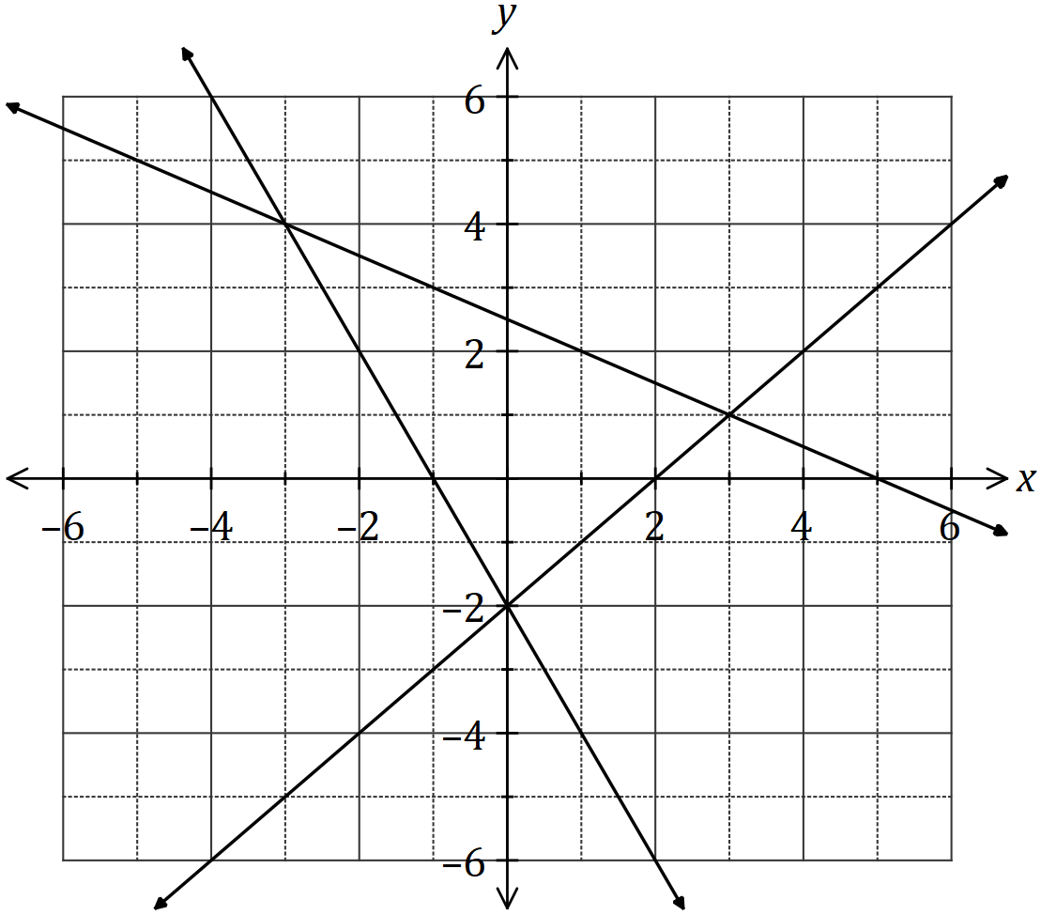

Using the graph, or otherwise, solve the simultaneous equations

|  |
| --- |
| **Solution** |
| $$x=0, y=-2$$ |
| **Specific behaviours** |
| ✓ value  ✓ value |

(i) $y=-2x-2$ and $y=x-2$. (2 marks)

|  |
| --- |
| **Solution** |
| $$x=-3, y=4$$ |
| **Specific behaviours** |
| ✓ value  ✓ value |

(ii) $y+2x=-2$ and $x=5-2y$. (2 marks)

(b) Solve the simultaneous equations $2a+3b=6$ and $2a-3b=18$. (3 marks)

|  |
| --- |
| **Solution** |
| $$2a+3b=6 \\ 2a-3b=18$$ $$4a=24$$ $$a=6$$ $$12+3b=6 \\ b=-2$$ |
| **Specific behaviours** |
| ✓ sum of equations  ✓ states value of  ✓ states value of $b$ |

Question 4 (8 marks)

The cost per metre of a fabric, usually $3.50, is reduced when larger quantities are purchased, as shown in this table.

|  |  |  |  |  |
| --- | --- | --- | --- | --- |
| Length of fabric purchased ( $x$ m) | $$0<x<5$$ | $$5≤x<10$$ | $$10≤x<25$$ | $$x≥25$$ |
| Cost per metre ( $C$ $) | $$3.50$$ | $$3.00$$ | $$2.50$$ | $$2.00$$ |

(a) Calculate the cost of buying 20 m of the fabric. (2 marks)

|  |
| --- |
| **Solution** |
| $$C=2.50 \text{per m}$$ $$C=2.50×20=\$50$$ |
| **Specific behaviours** |
| ✓ uses correct cost per metre  ✓ states cost |

(b) Sketch a piece-wise graph of cost per metre against length purchased on the axes below. (3 marks)

|  |
| --- |
| **Solution** |
| See graph |
| **Specific behaviours** |
| ✓ four steps  ✓ correct end markers  ✓ uses ruler |

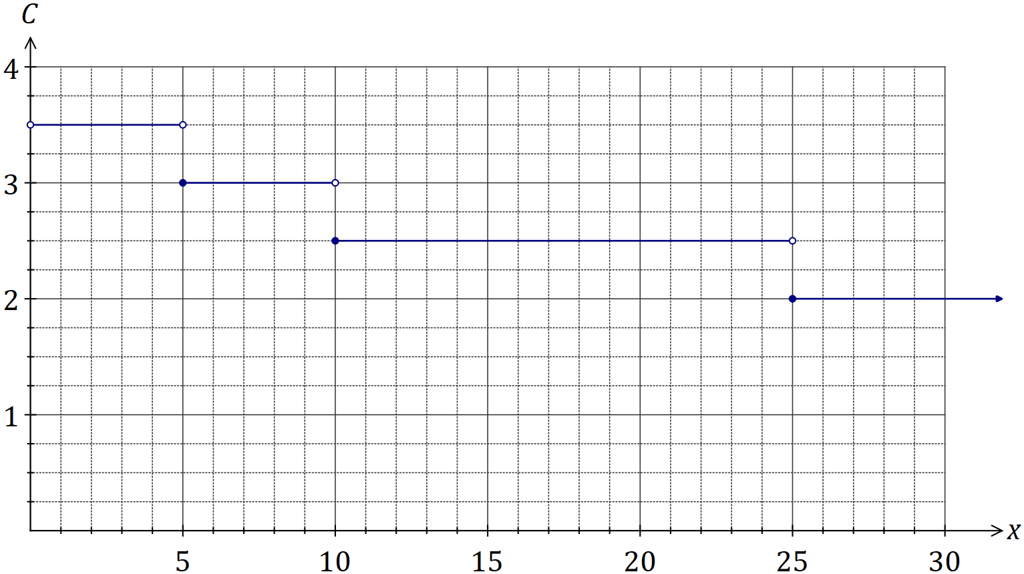

(c) A manufacturer has an order for 2 shirts per week that use this fabric, with each shirt requiring 1.5 metres of the material. Calculate the total saving made over a period of ten weeks if the manufacturer buys all the material at once, instead of weekly. (3 marks)

|  |
| --- |
| **Solution** |
| Weekly purchase: $2×1.5=3 \text{m}. 3×3.5=10.50 \text{per week, so total of \$105}$.  Bulk buy: $2×1.5×10=30 \text{m}. \text{Total}=30×2=\$60$ Saving: $\$45$ |
| **Specific behaviours** |
| ✓ calculates weekly cost  ✓ calculates bulk buy cost  ✓ states saving |

Question 5 (10 marks)

The cost of using electrician $A$ to install electrical appliances is shown below, where the cost is the sum of a fixed callout fee and a variable cost, depending on how many hours the job takes.

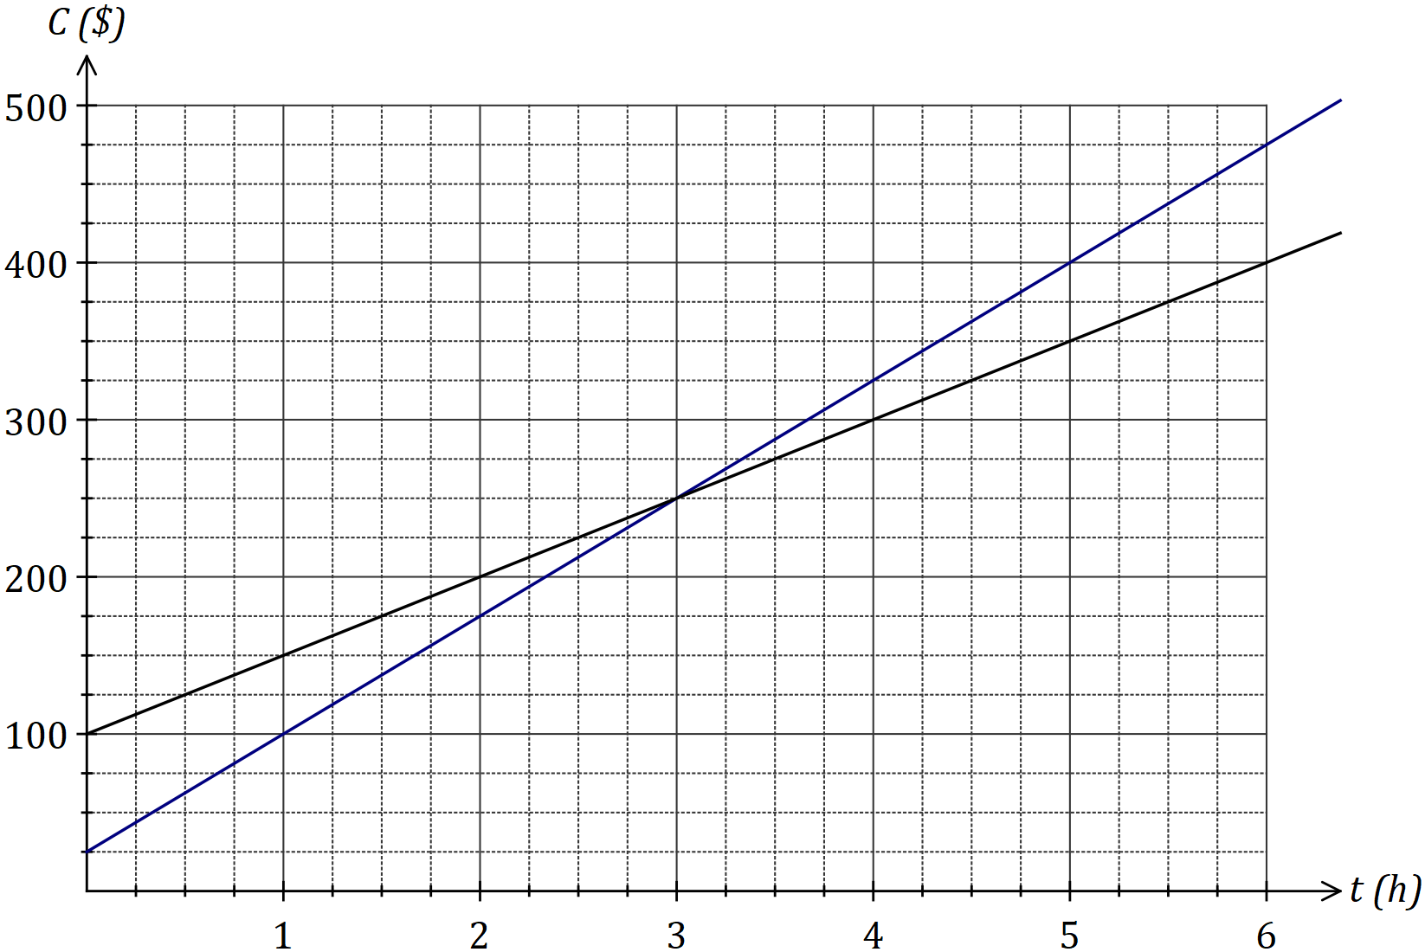

|  |
| --- |
| **Solution (d)** |
| See graph |
| **Specific behaviours** |
| ✓ first point  ✓ second points  -1 mark no ruler |

(a) State the cost of using electrician $A$ for a one-and-a-half-hour job. (1 mark)

|  |
| --- |
| **Solution** |
| $$C=\$175$$ |
| **Specific behaviours** |
| ✓ states exact cost |

(b) For electrician $A$, determine

(i) the fixed call out fee. (1 mark)

|  |
| --- |
| **Solution** |
| $$\text{Fee}=\$100$$ |
| **Specific behaviours** |
| ✓ states fee |

(ii) the hourly rate charged. (1 mark)

|  |
| --- |
| **Solution** |
| $$\text{Rate}=\$50 \text{per hour}$$ |
| **Specific behaviours** |
| ✓ states rate |

(c) State an equation that can be used to calculate the cost, $C$, of using electrician $A$ for a job lasting $t$ hours. (2 marks)

|  |
| --- |
| **Solution** |
| $$C=50t+100$$ |
| **Specific behaviours** |
| ✓ uses coefficients from (b)  ✓ correct formula |

(d) Electrician $B$ charges $175 for a 2-hour job and $400 for a 5-hour job. Given that the relationship between the job time and cost is linear, use these two points to add a line representing the cost of using electrician $B$ to the graph on the previous page.

(2 marks)

(e) State the call-out fee for electrician $B$. (1 mark)

|  |
| --- |
| **Solution** |
| $$\text{Fee}=\$25$$ |
| **Specific behaviours** |
| ✓ states fee |

(f) For what length of job

(i) do both electricians charge the same amount? (1 mark)

|  |
| --- |
| **Solution** |
| $$3 \text{hours}$$ |
| **Specific behaviours** |
| ✓ states time |

(ii) is electrician $A$ $25 more expensive than electrician $B$? (1 mark)

|  |
| --- |
| **Solution** |
| $$2 \text{hours}$$ |
| **Specific behaviours** |
| ✓ states time |

Question 6 (8 marks)

Six matrices are given by

$$A=\left[\begin{matrix}0 & -2 \\ 1 & 1\end{matrix}\right], B=\left[\begin{matrix}4 & -1 \\ -3 & 3\end{matrix}\right], C=\left[\begin{matrix}0 \\ 1\end{matrix}\right], D=\left[\begin{matrix}1 & 1\end{matrix}\right], E=\left[\begin{matrix}-2 \\ 5\end{matrix}\right], F=\left[\begin{matrix}6 & 5 \\ 8 & 7\end{matrix}\right].$$

(a) Calculate, where possible, the following. If not possible, give a reason why.

(i) $F-B$. (1 mark)

|  |
| --- |
| **Solution** |
| $$\left[\begin{matrix}6 & 5 \\ 8 & 7\end{matrix}\right]-\left[\begin{matrix}4 & -1 \\ -3 & 3\end{matrix}\right]=\left[\begin{matrix}2 & 6 \\ 11 & 4\end{matrix}\right]$$ |
| **Specific behaviours** |
| ✓ states difference |

(ii) $DA$. (1 mark)

|  |
| --- |
| **Solution** |
| $$\left[\begin{matrix}1 & 1\end{matrix}\right]×\left[\begin{matrix}0 & -2 \\ 1 & 1\end{matrix}\right]=\left[\begin{matrix}1 & -1\end{matrix}\right]$$ |
| **Specific behaviours** |
| ✓ states product |

(iii) $10C-2E$. (2 marks)

|  |
| --- |
| **Solution** |
| $$10\left[\begin{matrix}0 \\ 1\end{matrix}\right]-2\left[\begin{matrix}-2 \\ 5\end{matrix}\right]=\left[\begin{matrix}0 \\ 10\end{matrix}\right]-\left[\begin{matrix}-4 \\ 10\end{matrix}\right]=\left[\begin{matrix}4 \\ 0\end{matrix}\right]$$ |
| **Specific behaviours** |
| ✓ calculates multiples  ✓ states difference |

(iv) $AB$. (2 marks)

|  |
| --- |
| **Solution** |
| $$\left[\begin{matrix}0 & -2 \\ 1 & 1\end{matrix}\right]×\left[\begin{matrix}4 & -1 \\ -3 & 3\end{matrix}\right]=\left[\begin{matrix}6 & -6 \\ 1 & 2\end{matrix}\right]$$ |
| **Specific behaviours** |
| ✓ at least 2 elements correct  ✓ states product |

(b) If $G$ is the square of one of the above matrices, and $g_{22}=-1$, determine $g_{11}$. (2 marks)

|  |
| --- |
| **Solution** |
| $$G=A^{2}=\left[\begin{matrix}0 & -2 \\ 1 & 1\end{matrix}\right]\left[\begin{matrix}0 & -2 \\ 1 & 1\end{matrix}\right]=\left[\begin{matrix}-2 & … \\ … & -1\end{matrix}\right]$$ $$g_{11}=-2$$ |
| **Specific behaviours** |
| ✓ identifies matrix  ✓ states element |

Additional working space

Question number: _________

© 2017 WA Exam Papers. Kennedy Baptist College has a non-exclusive licence to copy and communicate this document for non-commercial, educational use within the school. No other copying, communication or use is permitted without the express written permission of WA Exam Papers. SN245-103-2.